TMT/Sriram/S0447/2025 03-09-2025

To,
Sriram,
Ph 9949084954.

Dear sir,

Sub :- Supply of 3 ROLLER Horizontal with pipe roll bending machine.

We are very much thankful to you for your enquiry regarding above bending machine. As requested by you we are submitting here under the detailed specifications

PRICE

1. Three roller horizontal bending machine for bending 100mm Dia and thickness maximum 2.5 mm with 5 hp drive gear box and gear system is Rs 6,75,000=00
(Rupees Six Lakh Seventy-Five Thousand Only)

GENERAL TERMS & CONDITIONS:

- Price quoted per unit ex-work. Hyderabad.
- Following charges are additional to your account.
- Freight Charge : As actual to be borne by you.
- Excise : 12.50%
- Sales Tax : 2% against form “C” else 14.5%
- Packing charge : As actual to be borne by you.
- Insurance : As actual to be borne by you.
- Payment : 50% advance alongwith order
balance before delivery but after inspection at our
works.
- Delivery : within 20 days from the date of advance.
- Validity : One month from the date of submission.
- Inspection : Inspection at our works prior to dispatch.
- Warranty : The machine is warranted for a period of 12
months from the date of dispatch against any
manufacturing defects/faulty material or bad
workmanship of any part or component but not
against any kind of abnormal or improper use of
machine. Defective part or component will be
replaced or repaired free of cost. Electrical
components are outside the scope of this
warranty.
- Commissioning : Erection & commissioning done by you, but if
required technical support & guidance provide by
us at additional cost.
NOTE:
- Oil is not in scope of our supply.
- Raw material for trial is arranged by you at your cost.

We are sure you will find our offer in line with your requirements. Should you require any further clarification please contact -9246221106/9849207176
Thanking you and assuring you of our best services.

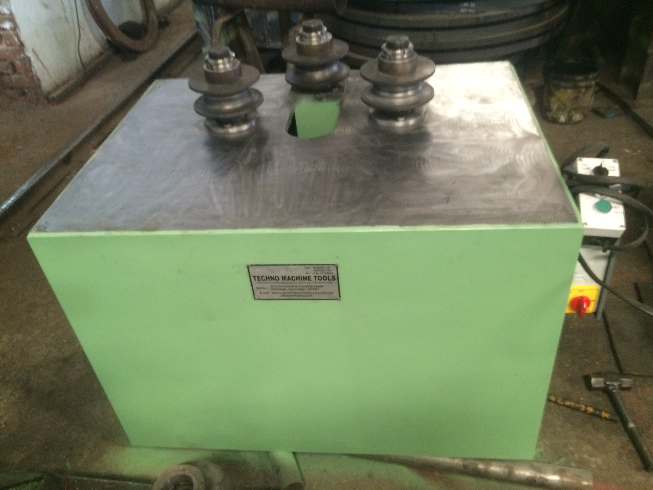
For TECHNO MACHINE TOOLS

( T. SIVARAMAKRISHNA)

